INDEX

Sr. No. | Date | Title | Pg. No. | Sign
1 |  | Write MongoDB queries to create a database and perform CRUD operations on an Employees collection
2 |  | Write a MongoDB script to perform CRUD operations on a Students collection
3 |  | Write MongoDB commands to perform CRUD operations on a Books collection
4 |  | Write a MapReduce program to count the occurrence of words
5 |  | Write a multi-stage MapReduce program to display word counts for words having at least 5 characters
6 |  | Perform Hive queries on a College database for data loading, filtering, aggregation, joins, partitioning and ranking
7 |  | Create a Student Academic database in Hive and perform queries for filtering, aggregation, classification and execution analysis
8 |  | Create an E-Commerce Sales database in Hive and perform queries using joins, aggregation, subqueries, functions and EXPLAIN

1. MongoDB – Employees CRUD Operations
Write a set of MongoDB queries to create a database and a collection named employees, and perform the following CRUD operations:
Create: Insert the following documents into the employees collection:
Name: Krutika Position: Manager Salary: 70000
Name: Harsh Position: Developer Salary: 55000
Name: Diya Position: HR Salary: 45000
Read: Retrieve all employees whose salary is greater than 50000.
Update: Increase the salary of all employees whose position is "Developer" by 10%.
Delete: Remove the employee named "Diya" from the collection.

CMDs:

use company_db

db.createCollection("employees")

db.employees.insertMany([

{

name: "Krutika",

position: "Manager",

salary: 70000

},

{

name: "Harsh",

position: "Developer",

salary: 55000

},

{

name: "Diya",

position: "HR",

salary: 45000

}

])

db.employees.find({

salary: { $gt: 50000 }

})

db.employees.deleteOne({

name: "Diya"

})

db.employees.find()

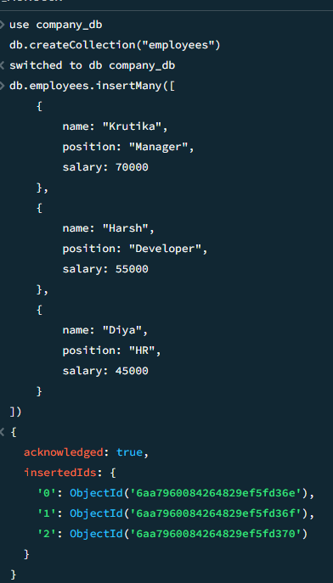

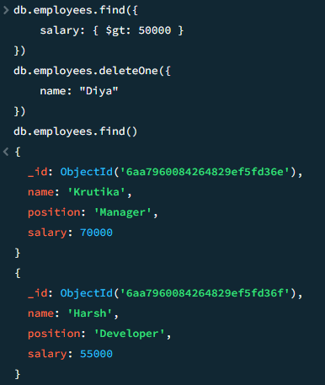

2. MongoDB – Students CRUD Operations
Write a MongoDB script to perform the following CRUD operations on a collection named students:
Create: Insert the following document into the students collection:
Name: Ankit Patel
Age: 22
Course: Computer Science
Read: Retrieve all students whose age is greater than 20.
Update: Update the course of the student named "Ankit Patel" to "Data Science".
Delete: Delete all students whose age is less than 21.

CMDs:

use student_db

db.createCollection("students")

db.students.insertOne({

name: "Ankit Patel",

age: 22,

course: "Computer Science"

})

db.students.find({

age: { $gt: 20 }

})

db.students.updateOne(

{ name: "Ankit Patel" },

{ $set: { course: "Data Science" } }

)

db.students.deleteMany({

age: { $lt: 21 }

})

db.students.find()

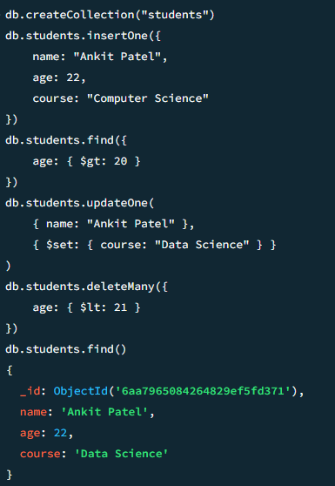

3. MongoDB – Books CRUD Operations
Write MongoDB commands to perform the following CRUD operations on a collection named books:
Create: Insert the following book document:
Title: Programming in C
Author: ABC
Published Year: 2001
Copies Sold: 65000000
Read: Find all books that were published before the year 2000.
Update: Add a field rating with the value 4.8 to the book titled "Programming in C".
Delete: Delete all books where copiesSold is less than 1000000.

CMDs:

use library_db

db.createCollection("books")

db.books.insertOne({

title: "Programming in C",

author: "ABC",

publishedYear: 2001,

copiesSold: 65000000

})

db.books.find({

publishedYear: { $lt: 2000 }

})

db.books.updateOne(

{ title: "Programming in C" },

{ $set: { rating: 4.8 } }

)

db.books.deleteMany({

copiesSold: { $lt: 1000000 }

})

db.books.find()

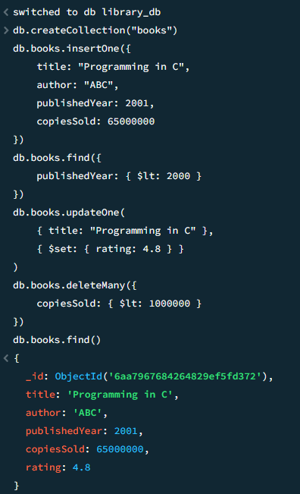

4. MapReduce – Word Count
Write a MapReduce program to count the occurrence of each word in a given input text file.
The program should use:
- Mapper
- Reducer
- Driver/Main class
The output should display each word along with its total count.

CMDs:

1. WordCountMapper.java

import java.io.IOException;

import org.apache.hadoop.io.IntWritable;

import org.apache.hadoop.io.Text;

import org.apache.hadoop.mapreduce.Mapper;

public class WordCountMapper

extends Mapper<Object, Text, Text, IntWritable> {

private final static IntWritable one = new IntWritable(1);

private Text word = new Text();

public void map(Object key, Text value, Context context)

throws IOException, InterruptedException {

String[] words = value.toString().split("\\s+");

for (String w : words) {

word.set(w);

context.write(word, one);

}

}

}

2. WordCountReducer.java

import java.io.IOException;

import org.apache.hadoop.io.IntWritable;

import org.apache.hadoop.io.Text;

import org.apache.hadoop.mapreduce.Reducer;

public class WordCountReducer

extends Reducer<Text, IntWritable, Text, IntWritable> {

private IntWritable result = new IntWritable();

public void reduce(Text key, Iterable<IntWritable> values,

Context context)

throws IOException, InterruptedException {

int sum = 0;

for (IntWritable value : values) {

sum += value.get();

}

result.set(sum);

context.write(key, result);

}

}

3. WordCountDriver.java

import org.apache.hadoop.conf.Configuration;

import org.apache.hadoop.fs.Path;

import org.apache.hadoop.io.IntWritable;

import org.apache.hadoop.io.Text;

import org.apache.hadoop.mapreduce.Job;

import org.apache.hadoop.mapreduce.lib.input.FileInputFormat;

import org.apache.hadoop.mapreduce.lib.output.FileOutputFormat;

public class WordCountDriver {

public static void main(String[] args) throws Exception {

Configuration conf = new Configuration();

Job job = Job.getInstance(conf, "Word Count");

job.setJarByClass(WordCountDriver.class);

job.setMapperClass(WordCountMapper.class);

job.setReducerClass(WordCountReducer.class);

job.setOutputKeyClass(Text.class);

job.setOutputValueClass(IntWritable.class);

FileInputFormat.addInputPath(job, new Path(args[0]));

FileOutputFormat.setOutputPath(job, new Path(args[1]));

System.exit(job.waitForCompletion(true) ? 0 : 1);

}

}

4. Sample Input

Create a file named input.txt:

hello hadoop

hello world

hadoop is big data

5. Create Input Directory in HDFS

hdfs dfs -mkdir -p /wordcount/input

Upload the input file:

hdfs dfs -put input.txt /wordcount/input/

Check the file:

hdfs dfs -cat /wordcount/input/input.txt

6. Compile the Program

javac -classpath "$(hadoop classpath)" -d . WordCountMapper.java WordCountReducer.java WordCountDriver.java

Create the JAR file:

jar -cvf wordcount.jar *.class

7. Run the MapReduce Program

hadoop jar wordcount.jar WordCountDriver /wordcount/input /wordcount/output

8. Display Output

hdfs dfs -cat /wordcount/output/part-r-00000
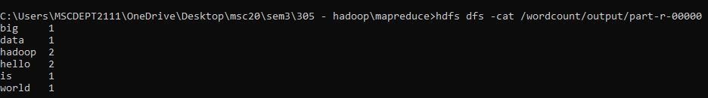

5. Multi-Stage MapReduce – Word Filtering and Counting
Write a multi-stage MapReduce program to display the word count of words having at least 5 characters.
The program should:
- Read words from the input file.
- Filter out words having fewer than 5 characters.
- Count the occurrences of the remaining words.
- Display each qualifying word along with its count.

For this practical, we will use two MapReduce stages:

Stage 1: Filter words having at least 5 characters

Stage 2: Count the occurrences of the filtered words

We will create 5 Java files:

WordFilterMapper.java

WordFilterReducer.java

WordCountMapper.java

WordCountReducer.java

MultiStageDriver.java

Stage 1 — Filter Words

1. WordFilterMapper.java

import java.io.IOException;

import org.apache.hadoop.io.IntWritable;

import org.apache.hadoop.io.Text;

import org.apache.hadoop.mapreduce.Mapper;

public class WordFilterMapper

extends Mapper<Object, Text, Text, IntWritable> {

private final static IntWritable one = new IntWritable(1);

private Text word = new Text();

public void map(Object key, Text value, Context context)

throws IOException, InterruptedException {

String[] words = value.toString().split("\\s+");

for (String w : words) {

w = w.replaceAll("[^a-zA-Z]", "");

if (w.length() >= 5) {

word.set(w.toLowerCase());

context.write(word, one);

}

}

}

}

2. WordFilterReducer.java

import java.io.IOException;

import org.apache.hadoop.io.IntWritable;

import org.apache.hadoop.io.Text;

import org.apache.hadoop.mapreduce.Reducer;

public class WordFilterReducer

extends Reducer<Text, IntWritable, Text, IntWritable> {

public void reduce(Text key, Iterable<IntWritable> values,

Context context)

throws IOException, InterruptedException {

context.write(key, new IntWritable(1));

}

}

Stage 2 — Count Filtered Words

3. WordCountMapper.java

import java.io.IOException;

import org.apache.hadoop.io.IntWritable;

import org.apache.hadoop.io.Text;

import org.apache.hadoop.mapreduce.Mapper;

public class WordCountMapper

extends Mapper<Object, Text, Text, IntWritable> {

private final static IntWritable one = new IntWritable(1);

private Text word = new Text();

public void map(Object key, Text value, Context context)

throws IOException, InterruptedException {

String[] parts = value.toString().split("\\s+");

if (parts.length >= 1) {

word.set(parts[0]);

context.write(word, one);

}

}

}

4. WordCountReducer.java

import java.io.IOException;

import org.apache.hadoop.io.IntWritable;

import org.apache.hadoop.io.Text;

import org.apache.hadoop.mapreduce.Reducer;

public class WordCountReducer

extends Reducer<Text, IntWritable, Text, IntWritable> {

private IntWritable result = new IntWritable();

public void reduce(Text key, Iterable<IntWritable> values,

Context context)

throws IOException, InterruptedException {

int sum = 0;

for (IntWritable value : values) {

sum += value.get();

}

result.set(sum);

context.write(key, result);

}

}

5. MultiStageDriver.java

import org.apache.hadoop.conf.Configuration;

import org.apache.hadoop.fs.Path;

import org.apache.hadoop.io.IntWritable;

import org.apache.hadoop.io.Text;

import org.apache.hadoop.mapreduce.Job;

import org.apache.hadoop.mapreduce.lib.input.FileInputFormat;

import org.apache.hadoop.mapreduce.lib.output.FileOutputFormat;

public class MultiStageDriver {

public static void main(String[] args) throws Exception {

Configuration conf = new Configuration();

// ---------------- STAGE 1 ----------------

Job job1 = Job.getInstance(conf, "Filter Words");

job1.setJarByClass(MultiStageDriver.class);

job1.setMapperClass(WordFilterMapper.class);

job1.setReducerClass(WordFilterReducer.class);

job1.setOutputKeyClass(Text.class);

job1.setOutputValueClass(IntWritable.class);

FileInputFormat.addInputPath(job1, new Path(args[0]));

Path stage1Output = new Path(args[1]);

FileOutputFormat.setOutputPath(job1, stage1Output);

if (!job1.waitForCompletion(true)) {

System.exit(1);

}

// ---------------- STAGE 2 ----------------

Job job2 = Job.getInstance(conf, "Count Filtered Words");

job2.setJarByClass(MultiStageDriver.class);

job2.setMapperClass(WordCountMapper.class);

job2.setReducerClass(WordCountReducer.class);

job2.setOutputKeyClass(Text.class);

job2.setOutputValueClass(IntWritable.class);

FileInputFormat.addInputPath(job2, stage1Output);

FileOutputFormat.setOutputPath(job2, new Path(args[2]));

System.exit(job2.waitForCompletion(true) ? 0 : 1);

}

}

6. Sample Input

Create a file named input.txt:

hello hadoop world

hello programming

hadoop programming language

big data technology

7. Create HDFS Input Directory

hdfs dfs -mkdir -p /multistage/input

Upload the file:

hdfs dfs -put input.txt /multistage/input/

8. Compile the Java Files

javac -classpath "$(hadoop classpath)" -d . WordFilterMapper.java WordFilterReducer.java WordCountMapper.java WordCountReducer.java MultiStageDriver.java

Create the JAR:

jar -cvf multistage.jar *.class

9. Run the Program

hadoop jar multistage.jar MultiStageDriver /multistage/input /multistage/stage1 /multistage/output

10. Display Final Output

hdfs dfs -cat /multistage/output/part-r-00000

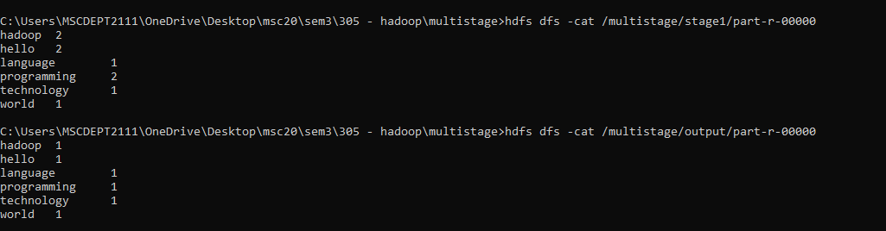

6. Hive – College Database and Query Exercises
Perform the following HiveQL operations on a database named college_db:
- Create a database named college_db.
CREATE DATABASE college_db;
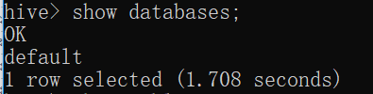
- Switch to the college_db database.
USE college_db;
- Create a table named students with the following fields:
id INT
name STRING
age INT
department STRING
marks INT

CREATE TABLE students (
id INT,
name STRING,
age INT,
department STRING,
marks INT
);
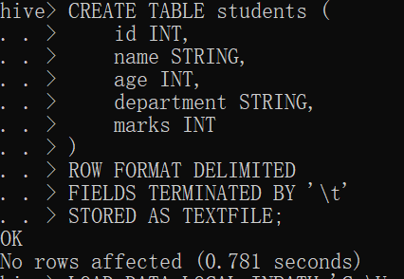
- Load data from a local file into the students table.
students.txt file:
1 Shraddha 22 Computer Science 85
2 Ankit 21 Computer Science 78
3 Priya 23 Information Technology 92
4 Rahul 20 Computer Science 65
5 Neha 22 Electronics 74
6 Karan 24 Information Technology 88
7 Diya 21 Electronics 69
8 Harsh 23 Computer Science 81
Load the file:
LOAD DATA LOCAL INPATH '/path/to/students.txt'
INTO TABLE students;
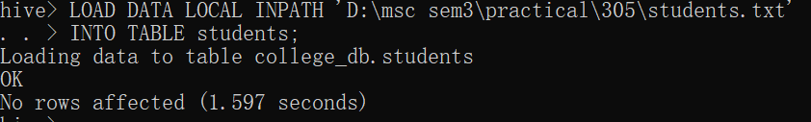
- Display all records from the table.
SELECT * FROM students;
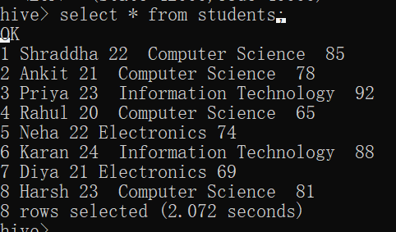
- Display only the names and marks of students.
SELECT name, marks FROM students;
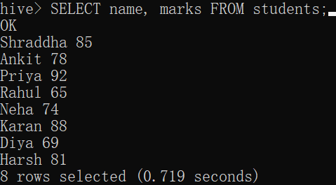
- Find students who are older than 20.
SELECT * FROM students WHERE age > 20;
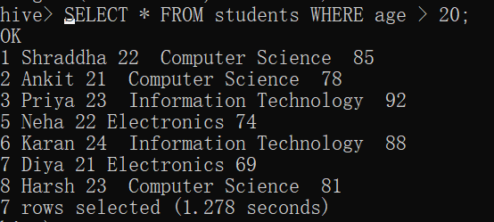
- Retrieve students belonging to the "Computer Science" department.
SELECT * FROM students WHERE department = 'Computer Science'; 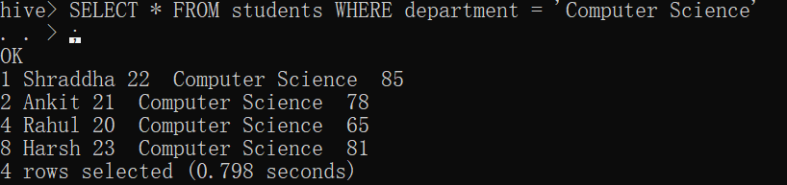
- Find students who scored between 60 and 80.
SELECT * FROM students WHERE marks BETWEEN 60 AND 80;
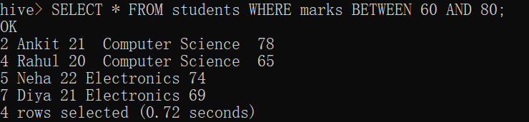
- Sort students by marks in descending order.
SELECT * FROM students ORDER BY marks DESC;

- Find the total number of students.
SELECT COUNT(*) AS total_students FROM students;
- Find the average marks of students.
SELECT AVG(marks) AS average_marks FROM students;
- Find the maximum and minimum marks.
SELECT MAX(marks) AS maximum_marks,MIN(marks) AS minimum_marks
FROM students;
- Find the total number of students in each department.
SELECT department, COUNT(*) AS total_students FROM students
GROUP BY department;
- Find the average marks of students in each department.
SELECT department, AVG(marks) AS average_marks FROM students
GROUP BY department;
- Create another table named departments with the following fields:
id INT
dept_name STRING
hod STRING
Insert a few records into the departments table and perform an INNER JOIN between the students and departments tables.
CREATE TABLE departments (
id INT,
dept_name STRING,
hod STRING
);
INSERT INTO departments VALUES
(101, 'Computer Science', 'Dr. Mehta'),
(102, 'Information Technology', 'Dr. Shah'),
(103, 'Electronics', 'Dr. Patel'),
(104, 'Mechanical', 'Dr. Desai');
SELECT s.id, s.name,s.department, d.hod FROM students s
INNER JOIN departments d
ON s.department = d.dept_name;
- Perform a LEFT JOIN to display all students, even if their department does not have a matching record.
SELECT s.id,s.name,s.department,d.hod
FROM students s
LEFT JOIN departments d
ON s.department = d.dept_name;
- Find the top 3 students based on marks.
SELECT * FROM students ORDER BY marks DESC LIMIT 3;
- Find departments where the average marks are greater than 70.
SELECT department, AVG(marks) AS average_marks FROM students
GROUP BY department
HAVING AVG(marks) > 70;
- Use a subquery to find students whose marks are above the overall average marks.
SELECT * FROM students
WHERE marks > ( SELECT AVG(marks) FROM students );
- Create a partitioned table using department as the partition column.
CREATE TABLE students_partitioned (
id INT,
name STRING,
age INT,
marks INT
)
PARTITIONED BY (department STRING);
- Insert data into the partitioned table.
INSERT INTO TABLE students_partitioned
PARTITION (department = 'Computer Science')
SELECT id, name, age, marks
FROM students
WHERE department = 'Computer Science';
- Rank students based on their marks.
SELECT name,department, marks,
RANK() OVER (ORDER BY marks DESC) AS student_rank FROM students;
- Find the cumulative sum of marks for each department.
SELECT name,department,marks,
SUM(marks) OVER (
PARTITION BY department
ORDER BY marks
ROWS BETWEEN UNBOUNDED PRECEDING AND CURRENT ROW
) AS cumulative_marks
FROM students;

7. Hive – Student Academic Database

Database: student_db
Create a Hive database named student_db and a table named students with the following fields:
student_id
student_name
gender
age
course
semester
marks
city
Perform the following queries:
- Create the student_db database.
CREATE DATABASE student_db;
- Create the students table using suitable Hive data types.
USE student_db;
CREATE TABLE students (
student_id INT,
student_name STRING,
gender STRING,
age INT,
course STRING,
semester INT,
marks INT,
city STRING
);
- Insert the given student records.
INSERT INTO students VALUES
(1, 'Aarav Patel', 'Male', 21, 'M.Sc. CA', 3, 88, 'Ahmedabad'),
(2, 'Shraddha Tiwari', 'Female', 22, 'M.Sc. CA', 3, 92, 'Surat'),
(3, 'Priya Shah', 'Female', 21, 'M.Sc. CA', 2, 76, 'Ahmedabad'),
(4, 'Rahul Mehta', 'Male', 23, 'M.Sc. CA', 3, 68, 'Vadodara'),
(5, 'Ankit Patel', 'Male', 22, 'M.Sc. CA', 2, 81, 'Surat'),
(6, 'Neha Desai', 'Female', 21, 'M.Sc. CA', 1, 65, 'Mumbai'),
(7, 'Arjun Shah', 'Male', 24, 'M.Sc. CA', 3, 90, 'Ahmedabad'),
(8, 'Diya Patel', 'Female', 20, 'M.Sc. CA', 1, 72, 'Surat');
- Display all records.
SELECT * FROM students;
- Display only student name, course and marks.
SELECT student_name, course, marks FROM students;
- Find students whose marks are greater than 75.
SELECT * FROM students WHERE marks > 75;
- Find students whose marks are between 70 and 90.
SELECT * FROM students WHERE marks BETWEEN 70 AND 90;
- Find students belonging to Ahmedabad or Surat.
SELECT * FROM students WHERE city IN ('Ahmedabad', 'Surat');
- Sort students by marks in descending order.
SELECT * FROM students ORDER BY marks DESC;
- Find the maximum, minimum and average marks.
SELECT
MAX(marks) AS maximum_marks,
MIN(marks) AS minimum_marks,
AVG(marks) AS average_marks
FROM students;
- Count the total number of students.

- Find the average marks city-wise.
SELECT city, AVG(marks) AS average_marks FROM students
GROUP BY city;
- Find the number of students in each semester.
SELECT semester, COUNT(*) AS total_students FROM students
GROUP BY semester;
- Display students whose names start with "A".
SELECT * FROM students WHERE student_name LIKE 'A%';
- Use a CASE statement to classify students as follows:
Excellent → Marks >= 85
Good → Marks >= 70
Average → Marks < 70

SELECT
student_name,
marks,
CASE
WHEN marks >= 85 THEN 'Excellent'
WHEN marks >= 70 THEN 'Good'
ELSE 'Average'
END AS performance
FROM students;

- Use EXPLAIN to examine the query execution plan.
EXPLAIN SELECT * FROM students WHERE marks > 75;

8. Hive – E-Commerce Sales Database

Database: ecommerce_db
Create a Hive database named ecommerce_db.
CREATE DATABASE ecommerce_db;
USE ecommerce_db;
Create the following three tables:

Table 1: customers
customer_id
customer_name
city
State

CREATE TABLE customers (
customer_id INT,
customer_name STRING,
city STRING,
state STRING
);

Table 2: products
product_id
product_name
category
Price

CREATE TABLE products (
product_id INT,
product_name STRING,
category STRING,
price DOUBLE
);

Table 3: orders
order_id
customer_id
product_id
quantity
Order_date

CREATE TABLE orders (
order_id INT,
customer_id INT,
product_id INT,
quantity INT,
order_date STRING
);

Perform the following queries:
- Create the ecommerce_db database.
- Create all three tables.
- Insert the supplied data into the tables.
INSERT INTO customers VALUES
(1, 'Aarav Patel', 'Ahmedabad', 'Gujarat'),
(2, 'Shraddha Tiwari', 'Surat', 'Gujarat'),
(3, 'Priya Shah', 'Vadodara', 'Gujarat'),
(4, 'Rahul Mehta', 'Mumbai', 'Maharashtra'),
(5, 'Ankit Patel', 'Ahmedabad', 'Gujarat');
INSERT INTO products VALUES
(101, 'Laptop', 'Electronics', 55000),
(102, 'Smartphone', 'Electronics', 25000),
(103, 'Office Chair', 'Furniture', 12000),
(104, 'Keyboard', 'Accessories', 1500),
(105, 'Monitor', 'Electronics', 18000);
INSERT INTO orders VALUES
(1001, 1, 101, 1, '2026-01-10'),
(1002, 2, 102, 1, '2026-01-12'),
(1003, 1, 103, 2, '2026-01-15'),
(1004, 3, 104, 2, '2026-01-18'),
(1005, 4, 105, 1, '2026-01-20'),
(1006, 5, 102, 2, '2026-01-22'),
(1007, 2, 104, 3, '2026-01-25'),
(1008, 1, 105, 1, '2026-01-28');
- Display all customers.
SELECT * FROM customers;
- Display products costing more than ₹10,000.
SELECT * FROM products WHERE price > 10000;
- Find the total number of orders.
SELECT COUNT(*) AS total_orders FROM orders;
- Calculate the order value using:
Order Value = Quantity × Price

SELECT
o.order_id,
o.product_id,
o.quantity,
p.price,
o.quantity * p.price AS order_value
FROM orders o
JOIN products p
ON o.product_id = p.product_id;
- Perform a JOIN between the customers and orders tables.
SELECT
c.customer_name,
o.order_id,
o.order_date
FROM customers c
JOIN orders o
ON c.customer_id = o.customer_id;
- Join all three tables and display:
Customer Name
Product Name
Quantity
Price
Order Value

SELECT
c.customer_name,
p.product_name,
o.quantity,
p.price,
o.quantity * p.price AS order_value
FROM customers c
JOIN orders o
ON c.customer_id = o.customer_id
JOIN products p
ON o.product_id = p.product_id;
- Find total sales by product.
SELECT
p.product_name,
SUM(o.quantity * p.price) AS total_sales
FROM products p
JOIN orders o
ON p.product_id = o.product_id
GROUP BY p.product_name;
- Find total sales by customer.
SELECT
c.customer_name,
SUM(o.quantity * p.price) AS total_purchase
FROM customers c
JOIN orders o
ON c.customer_id = o.customer_id
JOIN products p
ON o.product_id = p.product_id
GROUP BY c.customer_name;
- Find the highest-value order.
SELECT
o.order_id,
c.customer_name,
p.product_name,
o.quantity,
p.price,
o.quantity * p.price AS order_value
FROM orders o
JOIN customers c
ON o.customer_id = c.customer_id
JOIN products p
ON o.product_id = p.product_id
ORDER BY order_value DESC
LIMIT 1;
- Find the average product price by category.
SELECT category, AVG(price) AS average_price FROM products
GROUP BY category;
- Find customers whose total purchase is greater than ₹30,000 using a subquery.
SELECT customer_name
FROM customers
WHERE customer_id IN
(
SELECT o.customer_id
FROM orders o
JOIN products p
ON o.product_id = p.product_id
GROUP BY o.customer_id
HAVING SUM(o.quantity * p.price) > 30000
);
- Count the number of orders for each customer.
SELECT
c.customer_name,
COUNT(o.order_id) AS total_orders
FROM customers c
LEFT JOIN orders o
ON c.customer_id = o.customer_id
GROUP BY c.customer_name;
- Sort products according to total sales.
SELECT
p.product_name,
COALESCE(SUM(o.quantity * p.price), 0) AS total_sales
FROM products p
LEFT JOIN orders o
ON p.product_id = o.product_id
GROUP BY p.product_name
ORDER BY total_sales DESC;
- Use Hive built-in functions to format or manipulate order dates.
SELECT
order_id,
order_date,
YEAR(order_date) AS order_year,
MONTH(order_date) AS order_month,
DATE_FORMAT(order_date, 'dd-MM-yyyy') AS formatted_date
FROM orders;
- Use EXPLAIN on a three-table JOIN.
EXPLAIN
SELECT
c.customer_name,
p.product_name,
o.quantity
FROM customers c
JOIN orders o
ON c.customer_id = o.customer_id
JOIN products p
ON o.product_id = p.product_id;

